**Week 6 Lab Assembler**

**Group 65**

**Integrants: 110504517 李睿穎 (Leader)，110504518 鍾秉均 (Member)**

**Full Code**

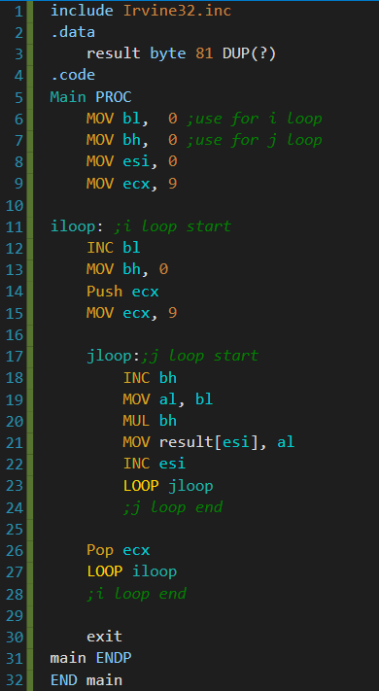

**Execution flow**

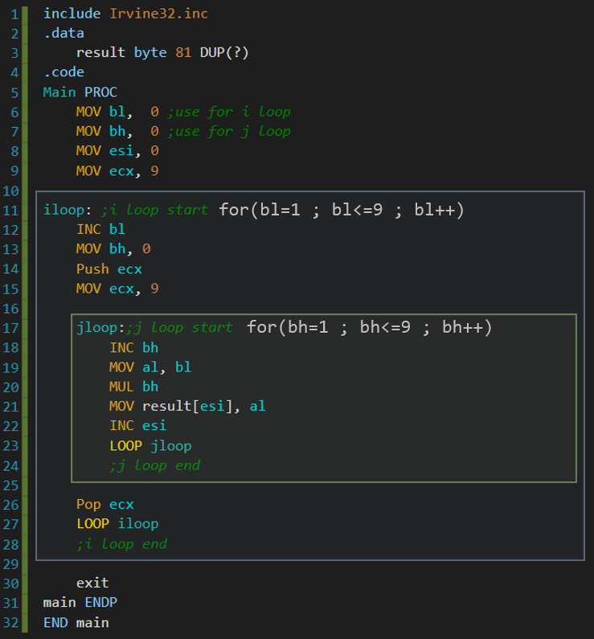

We divided the code in two rectangles for better explanation:

On the blue rectangle what we do is increasing our multiplicand and resetting our multiplier. We also push ecx so we can allow the second loop to utilize it.

What comes next is the green rectangle, which is inside the blue rectangle. What the code in it does is increasing the multiplier (bh) and multiplying it to our multiplicand (bl), when its done multiplying we move it to our result to the corresponding place in esi.

**Register and Flags in jloop**

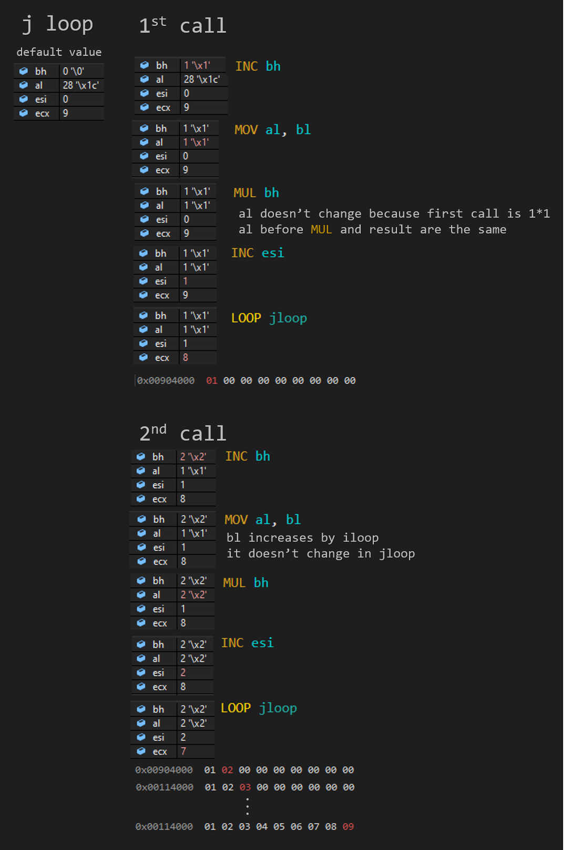

**Register and Flags in iloop**

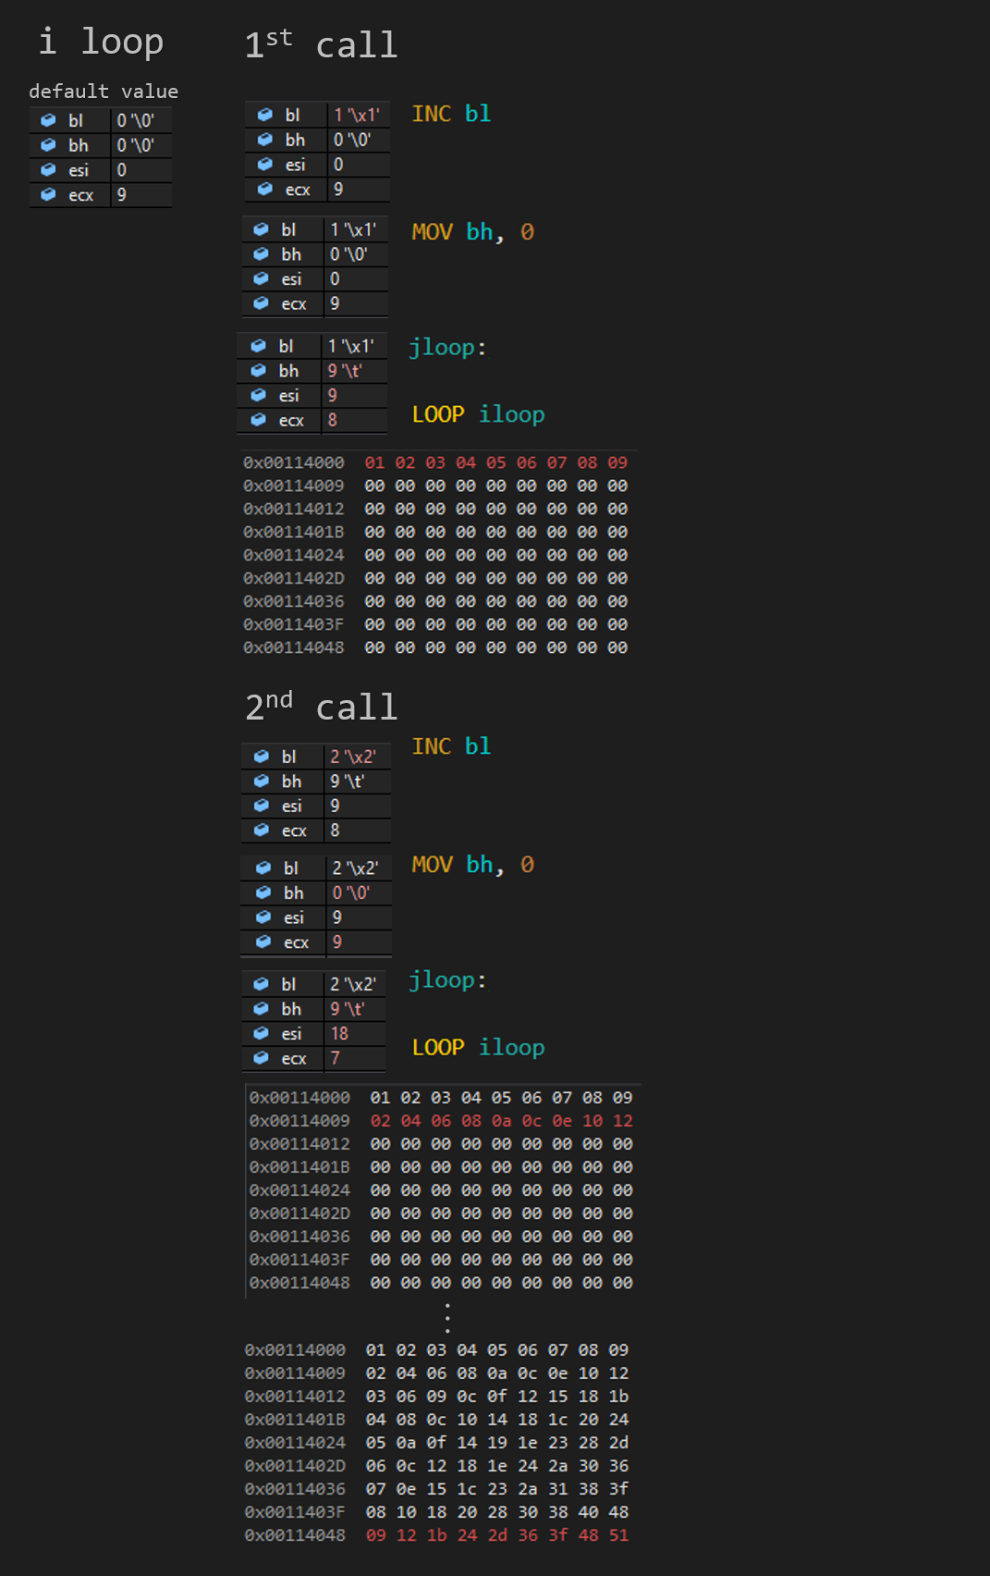

**Final result**

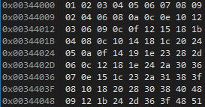

**Logic in high level language**

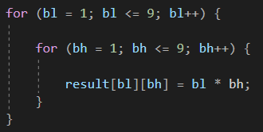

**Reflection**

Today’s lab experience was really interesting because it's the first time we use a double loop in assembler, It was somehow difficult for us because we needed to know where to increase and multiply our values. There was other things we had to do like pushing, popping ecx and where to loop, making today’s lab experience really tricky.

We also learnt how to do simple multiplication in assembler which is a lot more different than the languages we learnt this year, it is also somehow tricky because there is quite some knowledge you need to learn before using it.

In conclusion we can say today’s lab experience was rich.